Abstract

Members of the Spitzer Infrared Excess (SIRXS) team intend to isolate the Infrared Excess (IRXS) sources in the newly released Spitzer Enhance Imaging Products catalog (SEIP). Although Spitzer’s original cryogenic mission acquired images of roughly 42 million point sources, most of these were incidental and never targeted for research. The SEIP archive has, therefore, recorded millions of never before studied objects that just happened tobe in the same field of view as those objects specifically selected for research. This project intends to examine and cull all these data, isolating previously unknown IRXS candidates. There are three criteria. First, consider only those objects with signal to noise ratios (SNR) of at least 10 to 1, or ten sigma. Second, each source must satisfy this standard in all of the following five wave lengths: 3.6, 4.5, 5.8, 8 and 24 micrometers (µm). This reduced list of roughly one million sources will be analyzed by spreadsheet, using color-color ratios to identify our infrared candidates. Images of each potential IRXS source will then be examined by a team member to eliminate any obvious faulty images or misidentified IRXS sources. We currently have no expectation of what proportion of the 1 million sources (from the initial culling) will remain on the final list, as this is the first work resulting in statistical estimates of such a probability. Ultimately we will use color-magnitude diagrams to differentiate our list into three categories: Active Galactic Nuclei (AGN), Young Stellar Objects Sources (YSO) and exotic sources that fit neither of the first two categories. Our hope is that this SIRXS catalog will become an important resource for future researchers.

Background

(The physics of blackbodies would not be something you would describe in a proposal)
All astronomical objects produce black body curves.
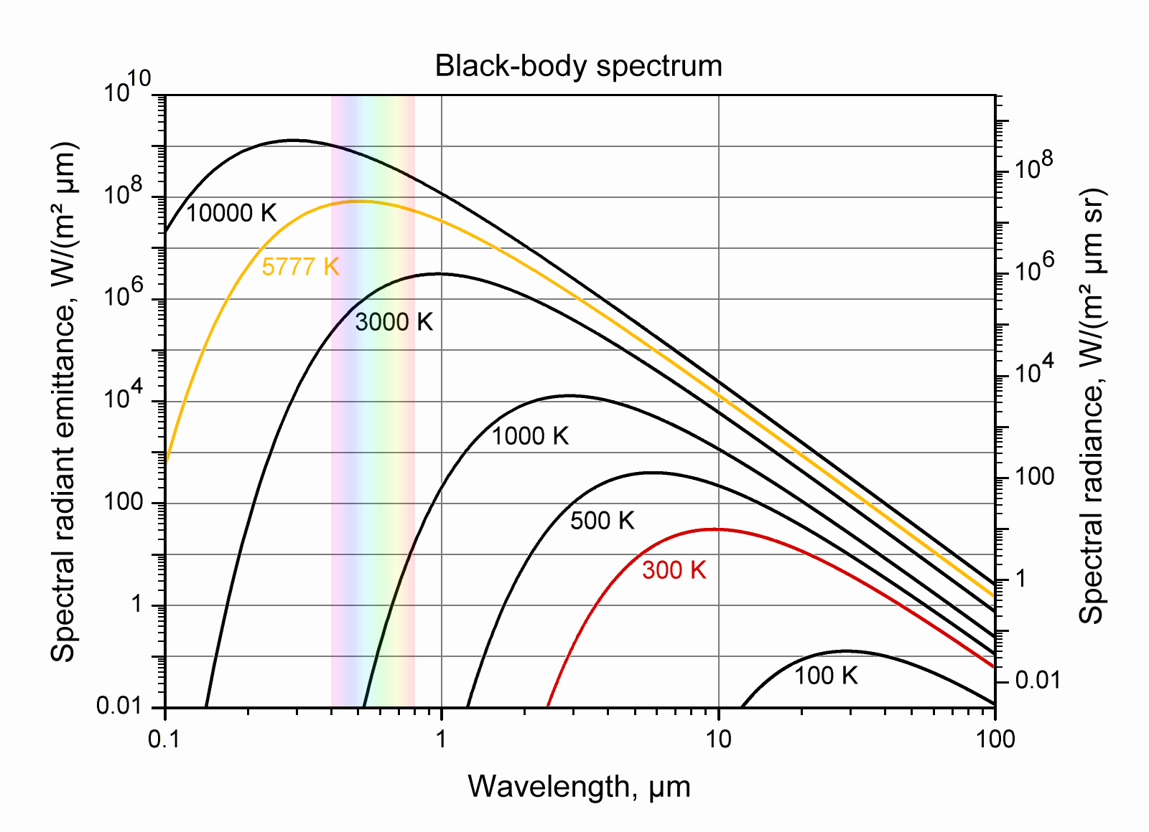
This last statement is not precisely true. Some astronomical bodies, AGN for example, emit light with two spectrographic peaks instead of a typical black body curve. The second peak is of lesser intensity and at larger wavelengths, which have lesser energy. This second peak is often in the infrared portion of the spectrum and is caused by a second body.
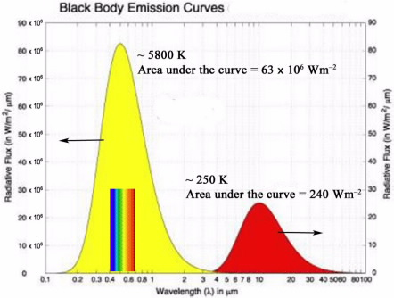

AGN are usually surrounded by a torus of dust, which absorbs energy from the mass falling into the black hole at the galaxy’s center. Some of this absorbed energy is re-emitted by the dust at a lower energy (the form of the energy is the same: photons, just at lower energies), thus producing the second (smaller) peak found in the infrared region of the spectrogram. This second peak is referred to as “infrared excess,” or IRXS. IRXS can also be caused by the reprocessing of the dust belt surrounding proto-stars and pre-main sequence stars. In this manner, infrared excess is usually caused by the heat given off of the secondary body of dust surrounding a primary (more luminous) celestial body.

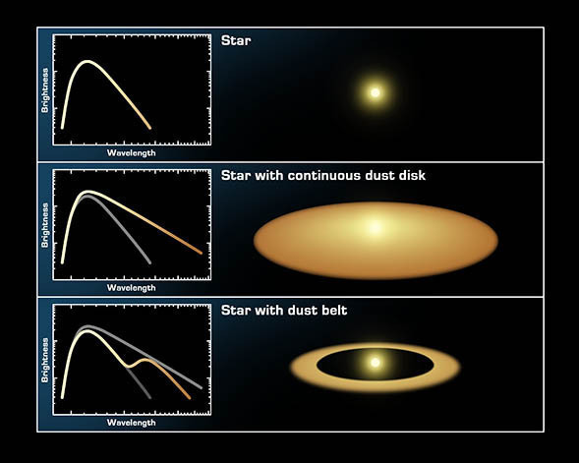
Detecting IRXS is a simple matter of identifying a light source with any deviance from the typical black body curve. While each black body curve may have a relatively unique peak in terms of its wavelength and intensity, the slopes of all black body curves, however, are conveniently similar. One way to determine the slope of a black body curve is to take a ratio of intensities at two different wavelengths. Although the actual numbers will vary from one curve to another, the ratios should remain about the same. This fact allows astronomers to determine the ratio of different wavelengths through out the Rayleigh-Jeans portion of the spectrum of a source and thereby identify the source as one with a black body curve, or a candidate for IRXS (the Rayleigh-Jean portion of the BB spectrum just identifies the longer portion of any curve so that it doesn’t have any wavelength limits and so is a more general statement than the “red, infrared, and radio portion”).

Spreadsheets of photometric data taken at different wavelengths can ease this analysis. A color-color diagram can be generated automatically to use a ratio of two wavelengths for the X-axis and a ratio of two different wavelengths for the Y-axis. This graph, below, is an example.

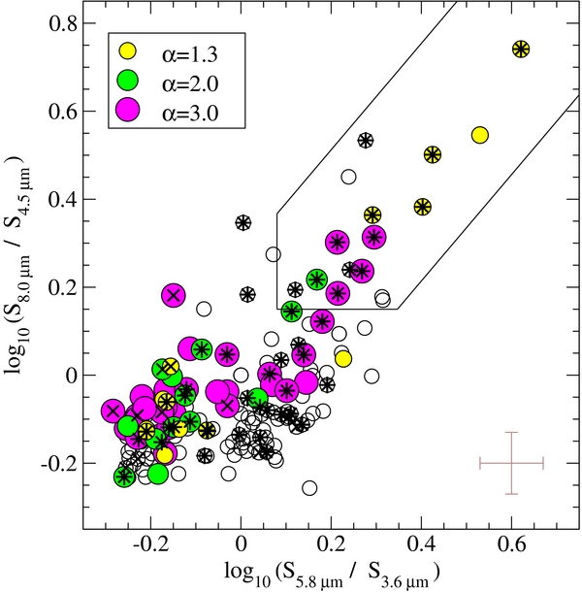

(Not necessary to describe what a color-color diagram is, at least not in so much detail) So the cluster of points at the lower left are typical celestial bodies. Those to the upper right of the origin all demonstrate some sort of IRXS.

The graph below is an example of a color-magnitude diagram. Ultimately, IRXS candidates will be graphed in this way because this allows us to make inferences about the type of IRXS source for each data point.

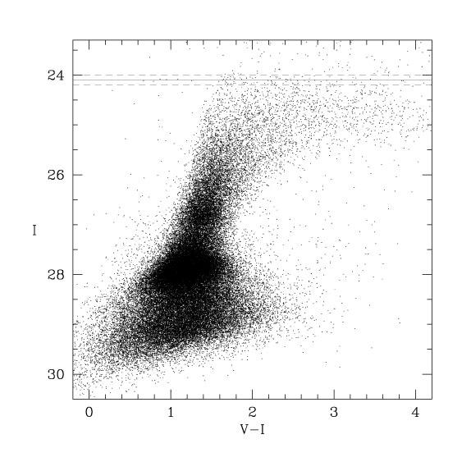

The X-axis above is a ratio of the difference of light intensity between the wavelength recorded with the V filter and the intensity of the light recorded with the I filter (no need to identify the microns of a filter if you have named it). Points plotted to the right deviate from the ideal black body curve between these wavelengths. The farther to the right, the greater the IRXS. The Y-axis, however, is the brightness of the sources. (Again the reviewers will know what a color-magnitude diagram is and so all you need to doo is say why you are using it here which you do very well in the following text) The brighter objects to the upper right are most likely YSO, while the dimmer bodies plotted to the lower left are probably AGN. This is simply a statistical assumption based upon the fact that dimmer, more distant objects are usually entire galaxies and celestial objects bright enough to be imaged individually are usually more nearby stars.

Scientific Goals

The scientific goals of this project are four. First, the main objective is to assemble a list of IRXS sources with a high confidence of ten sigmas in five channels (3.6, 4.5, 5.8, 8 and 24 µm) from the new SEIP catalog. Second, color-color diagrams and color-magnitude plots will be used to differentiate all identified IRXS sources into one of three categories: AGN, YSO or Exotic objects. Third, this IRXS-specific catalog will illuminate the specific percentage of each or our three individual types of ten sigma IRXS sources. Fourth, this IRXS catalog should prove an important and highly used resource for future research for years to come.

Expected Outcomes

Although we have no guesses as to the percentages of IRXS sources to be found within the scope and constraints of this study, we anticipate achieving all four of our stated Scientific Goals.

Archived Data

This project intends to rely primarily on the Spitzer Enhance Imaging Products catalog (SEIP). Our data may dictate the additional use of the tenth major data release, or DR10, of the Sloan Digital Sky Survey (SDSS) as well as the Two Micron All Sky Survey (2MASS). All of these data archives are in the public domain for non-comercial use at the NASA/IPAC Infrared Science Archive, managed and located on the CalTech campus in Pasadena, California.

Instruments

The primary imaging equipment used for the initial culling of data are two of the on-board Spitzer instruments from its initial cryogenic mission. They are the Infrared Array Camera (IRAC) for the 3.6 µm, 4.5 µm, 5.8 µm and 8 µm images and the Multiband Imaging Photometer for Spitzer (MIPS) for the 24 µm images. It is unlikely that the project will use data from the Infrared Spectrometer (IRS); however, it may be necessary to move to smaller wavelengths to properly graph the primary black body curve for some objects, which is necessary before an IRXS deviation can be determined. In such in instances, we will include photometric data taken at 2 µm by the Two Micron All-Sky Survey (2MASS). This whole sky survey concluded collecting data in 2003, which it did from ground based telescopes at two locations, Mt. Hopkins, Arizona for the Northern Hemisphere and Cerro Tololo Inter-American Observatory, Chile, for the Southern Hemisphere. We may also need to confirm data by referencing images taken at .893 µm from the tenth major data release, or DR10, of the Sloan Digital Sky Survey (SDSS). This is a ground based all sky survey using a 2.5 meter telescope and nitrogen cooled digital camera at the Apache Point Observatory in New Mexico.

Educational Goals

The educational goal driving Estes Park High School (EPHS) to participate in the NITARP study can be summarized as “determining the feasibility of successfully engaging students with original scientific research.” With luck, this project will be the beginning of a new trend for the Estes Park High School science department.

More specifically, four goals exist as part of this experiment.
- Can students rise to the responsibility required, the conceptual complexity involved, the time constraints imposed and the professional quality expected to make this project successful? (Do students have the capability?)
- Is multi-time zone collaboration between scientist-advisors and cooperating schools logistically feasible for this type of work? (Is this logistically possible?)
- Do the student experiences and achievements justify this level of energy expenditure? (Is it worth it?)
- Is productivity high enough to achieve our scientific goals? (Can we do it?)

References

Varoujan’s big brain and all the web sites which I plagiarized! (OK, I promise to complete this with high fidelity when we write our real proposal.)

