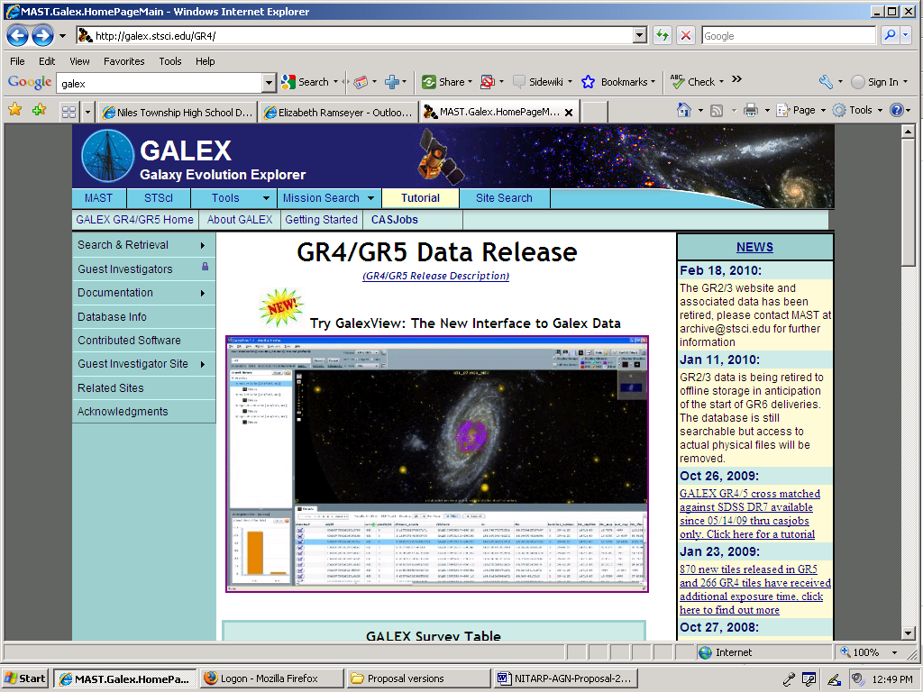
Click inside this window

GALEX Instructions
Google GALEX
Open first link.
Double click on the galaxy to open GALEX view.
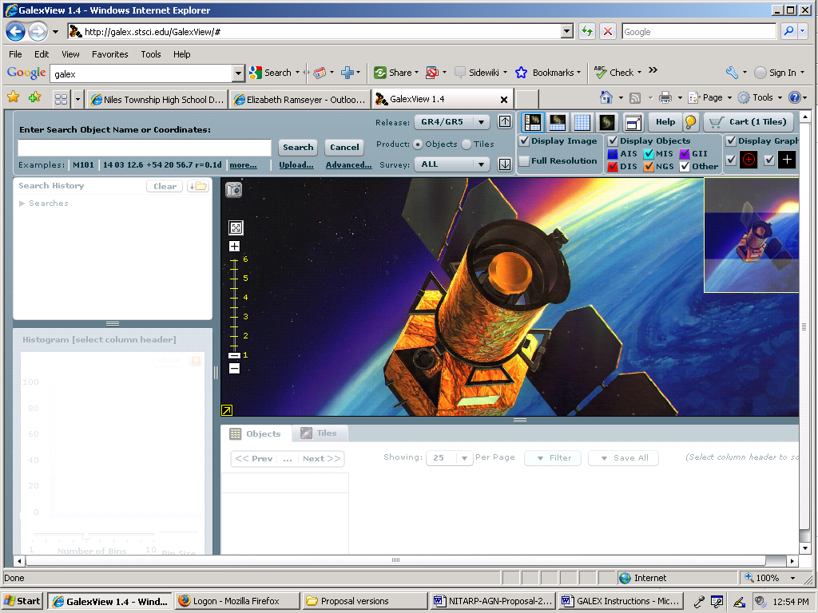
Type the object name here.

This window opens. Enter the Galaxy name (ex: NGC4639) and hit the search button.
This is what returns:

If you double click on a circle in the image, its color will change and then its objid will highlight in the list below. In addition, the information for that area will display above the objid list but below the image.

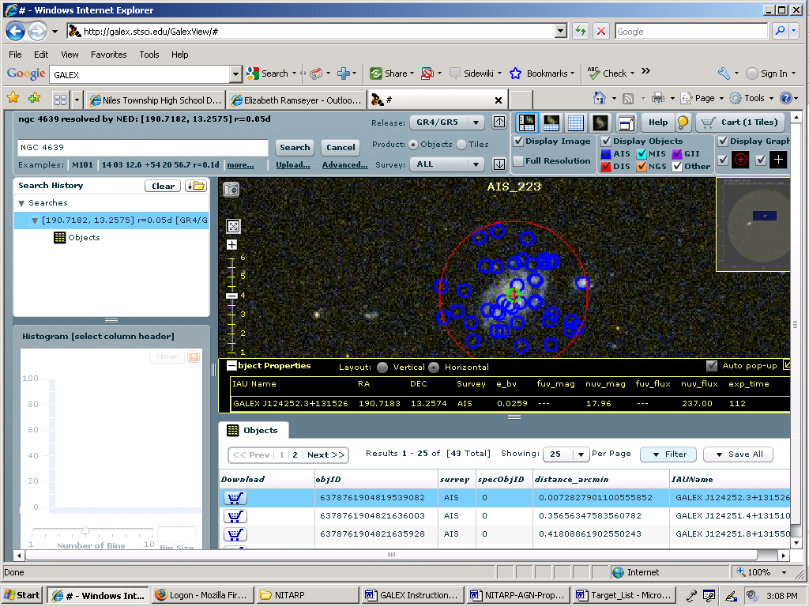
Needed information
objid

Clicking on the objID and will highlight a different circle target in the image. We want the central target.

