## Identification and Classification of Infrared Excess sources in the Spitzer Enhanced Imaging Products (SEIP) Catalog

Educator Team:

Todd Burke (Estes Park High School, Estes Park CO)

Linda Childs (Florida Virtual School, FL)

David Strasburger (Noble & Greenough School, Dedham MA)

Kevin Tambara (Bert Lynn Middle School, Los Angeles CA)

Mentor Teacher:

Caroline Odden (Phillips Academy, Andover MA)

Science Mentor:

Varoujan Gorjian (Jet Propulsion Laboratory, Pasadena CA)

Submitted March 7, 2014

## Abstract

Members of the SEIP Infrared Excess (SIRXS) team intend to isolate the Infrared Excess (IRXS) sources in the newly released Spitzer Enhanced Imaging Products catalog (SEIP). Although Spitzer’s original cryogenic mission acquired images of roughly 42 million point sources, most of these were incidental and never targeted for research. The SEIP archive has, therefore, recorded millions of never before studied objects that just happened to be in the same field of view as those objects specifically selected for research. This project intends to examine and cull all these data, isolating previously unknown IRXS candidates. There are three criteria. First, we will consider only those objects with signal to noise ratios (SNR) of at least 10 to 1, or ten sigma. Second, each source must satisfy this standard in all of the following five wavelengths: 3.6, 4.5, 5.8, 8 and 24 micrometers (µm). This reduced list of roughly one million sources will be analyzed by spreadsheet, using color-color ratios to identify our infrared excess candidates. Images of each potential IRXS source will then be examined by a team member to eliminate any obvious faulty images or misidentified IRXS sources. We currently have no expectation of what proportion of the one million sources (from the initial culling) will remain on the final list, as this is the first work resulting in statistical estimates of such a probability for the Spitzer archive. Ultimately we will use color-magnitude diagrams to differentiate our list into categories based on type of source. Our hope is that this SIRXS catalog will become an important resource for future researchers.

## Background

A variety of astronomical sources have been shown to produce the phenomenon known as infrared excess. In cases of infrared excess, the characteristic blackbody spectrum is evident at shorter wavelengths, but the curve exhibits a noticeable increase in the infrared. Many spectral energy distributions exhibiting infrared excess are well approximated by the superposition of two blackbody curves corresponding to sources with different temperatures. Infrared excess has been used to identify potential targets of study from large surveys since the discovery of a circumstellar shell around Vega by its infrared excess [Auman et al 1984]. There are four main categories of sources likely to exhibit excess infrared: young stars, evolved low- to intermediate-mass stars, active galactic nuclei (AGN), and interacting galaxies (e.g. ULIRGs). All four share the combination of a central source of energy with reprocessing by surrounding dust.

### 1. Young stars:

Young stellar objects (YSOs) may be embedded in a circumstellar envelope or disc of primordial dust not yet expelled, or by a debris field caused by the collision of forming protoplanets. In either case, the surrounding material is heated by the star or protostar and the target may be expected to exhibit excess infrared. [Mendoza and Eugenio 1966]

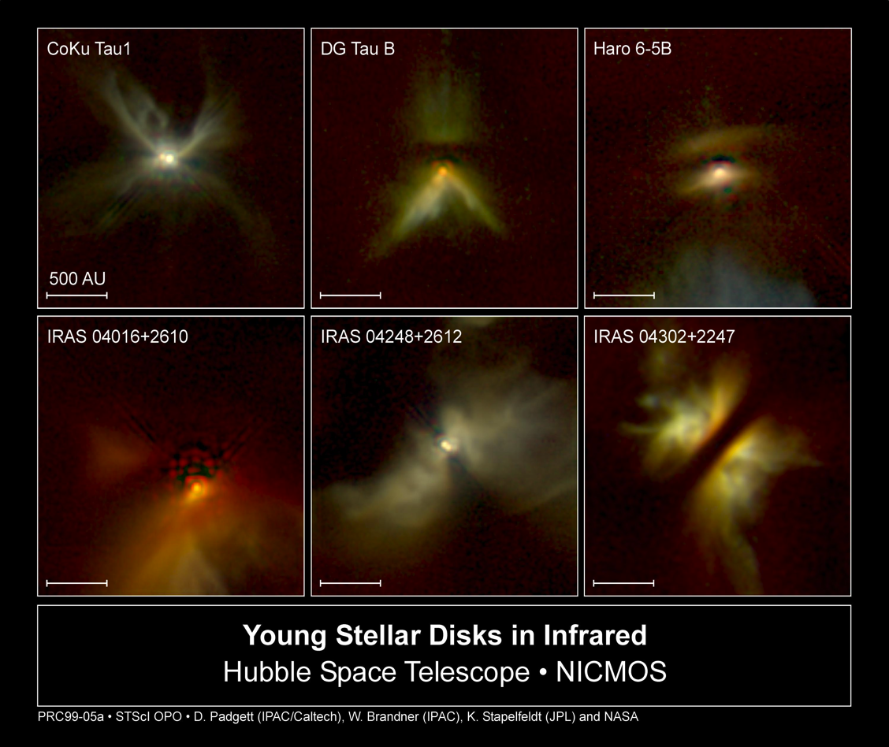

Figure 1: Three YSOs shown in visible and infrared with indications of cicumstellar dust

Excess infrared was used by a previous NITARP team to identify YSOs in bright-rimmed clouds. [Rebull et al 2013]

### 2. Evolved stars:

Low to intermediate mass stars eject 20 - 80 percent of their mass during the superwind phase at the end of the asymptotic giant branch of the Hertzsrpung-Russell Diagram. During the superwind, dust forms in the ejecta. [Wallerstein and Knapp 1998]

The resulting circumstellar dust reprocesses the radiation from the star and re-emits in the infrared.

### 3. Active Galactic Nuclei:

Infrared excess has been demonstrated as a successful technique for identifying active galactic nuclei (AGN) [e.g. Stern et al 2005]. Gas drawn from the surrounding galaxy forms a high-temperature accretion disk characterized by a blackbody spectrum peaking at ultraviolet wavelengths. It has been theorized that the disk may be enshrouded by a dusty torus of material also drawn from the surrounding galaxy [Antonucci 1993]. As it is heated, the torus reprocesses the radiation from the accretion disk by absorbing the optical and ultraviolet components and radiating in the infrared.

### 4. Colliding galaxies:

Ultraluminous infrared galaxies (ULIRGs) are interacting galaxies that exhibit exceptional intensity at infrared wavelengths.

Interaction between galaxies causes morphological distortion due to tidal forces [Toomre & Toomre 1972] and such distorted galaxies are distinct from normal ones on the (U-B, B-V) diagram. [Larson & Tinsley (1978](file://localhost/Users/faculty/Google%20Drive/NITARP%20_%20SIRXS/SIRXS%20proposal/MergedProposalReformatted.docx" \l "LarsonTinsley)) provides evidence for a 'burst' mode of star formation associated with the violent changes associated with galactic interaction.

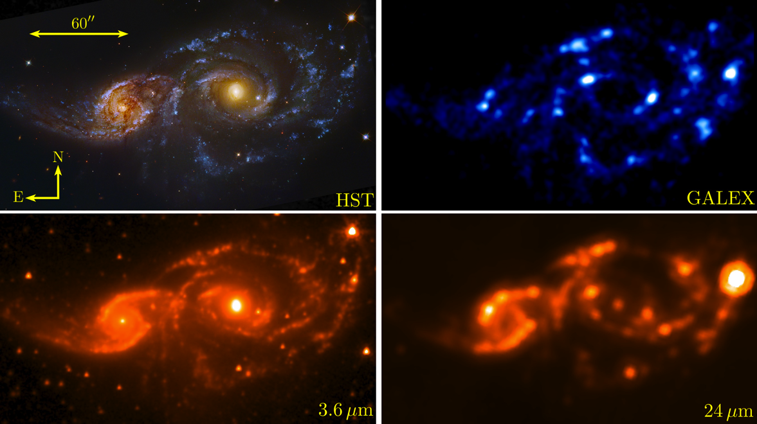

Figure 2: Merging galaxies NGC 2207 and IC2163 show regions of star formation

Lonsdale, Persson & Matthews (1984) and Joseph & Wright (1985) showed that interacting galaxies result in massive infrared excess due to star formation, and that interactions leading to merger are associated with “superstarbursts,” or “bursts of star formation of extraordinary intensity and spatial extent.”

Detecting IRXS is a simple matter of identifying a light source with a spectrum that deviates from that of a typical blackbody. Temperature determines the slope and peak emission wavelength of a blackbody curve; however, in log space the slopes of all blackbody curves are the same for λ>λmax, the region dubbed the Rayleigh-Jeans portion of the blackbody curve.



Figure 3: Theoretical blackbody spectra for 5000K (red) and 10000K (blue) objects have the same slope on the Rayleigh-Jeans tail ot the right of the peak emission.

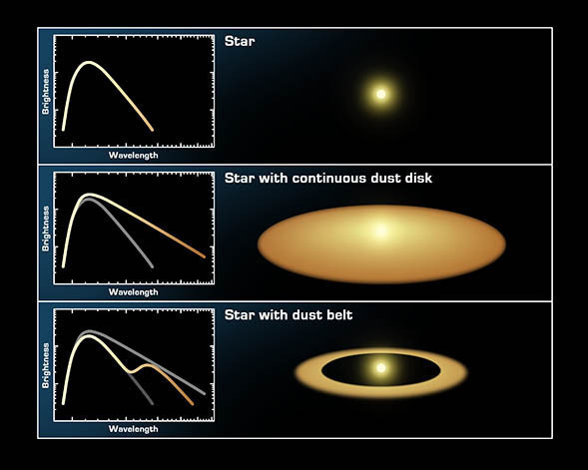

Figure 4: Dust surrounding a hot body results in a Rayleigh-Jeans tail with a different slope.

We say that a spectrum exhibits excess infrared if the slope of the Rayleigh-Jeans portion rises above the value predicted by theory for a single blackbody. In practice, the flux of a source is measured at a set of wavelengths corresponding to the channels of the instrument. (In Figure 3, the 3.6 and 4.5 µm IRAC channels are represented by the dashed vertical lines.) The slope of the tail is proportional to the difference in the fluxes measured at these two wavelengths, and this difference is used as the discriminating feature for IRXS. Ordinary sources may be expected to have roughly uniform slopes in this region; IRXS sources do not have tails with this ideal slope value.

Large numbers of sources may be collectively screened for IRXS by construction of a color-color diagram like the one in Figure 5. A color-color diagram plots the color of a source (in Fig. 5, say, the difference between the magnitude in the 3.4 and 4.5 µm bands) against a second color.

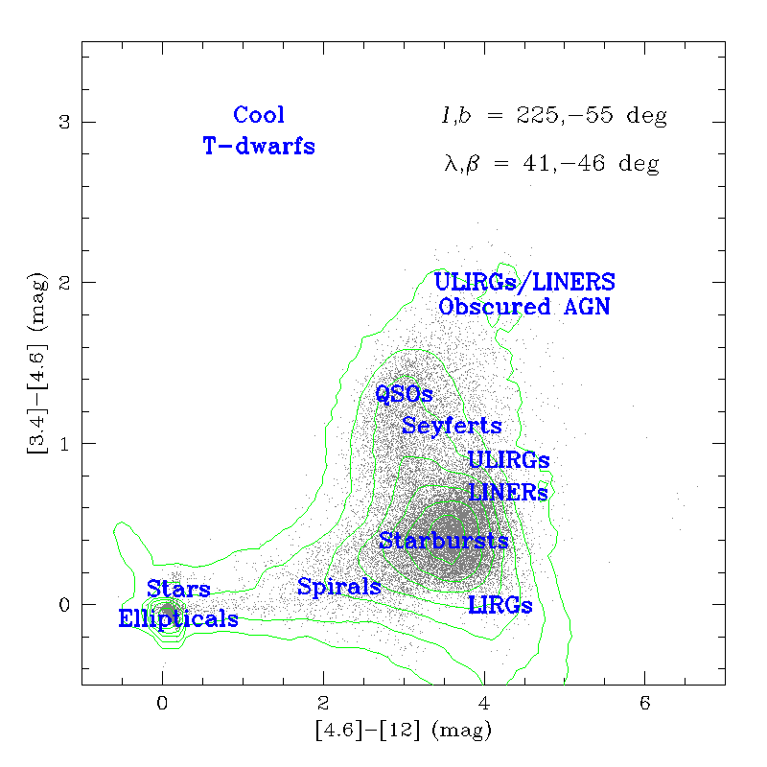

Figure 5: Color-color diagram from WISE preliminary data release.

Objects that do not exhibit IRXS will have colors near zero; as they do not deviate from a blackbody spectrum they clump near the origin. Objects exhibiting excess infrared may be expected to appear up and to the right on a color-color plot, as they do in figures 5 and 6.

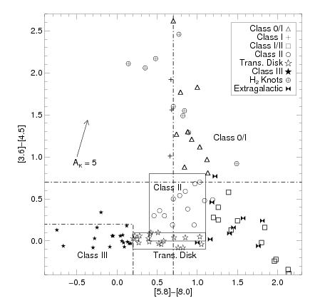

Figure 6: Color-color diagram of the young stellar population in bright-rimmed cloud SFO 38 [Choudhury *et al* 2010]

The new SEIP catalog presents an excellent opportunity to search for infrared excess in a large previously unstudied sample of objects. Although Spitzer’s original cryogenic mission acquired images of roughly 42 million point sources, most of these sources were not the intended targets of the images in which they appear and were acquired because of the large field of view of Spitzer’s cameras. The SEIP archive has, therefore, recorded millions of never before studied objects that incidentally happened to be in the same field of view as those objects specifically selected for research. This project intends to examine and cull all these data, isolating previously unknown IRXS candidates.

Our goals will be to determine what fraction of our sample exhibits infrared excess and to categorize as many sources as possible. In addition, we expect to develop a statistical profile of the sample. By determining how frequently various types of objects occur in the sample, we will be able to set expectations for the future. In particular, we expect to help inform expectations about the James Webb Space Telescope (JWST) mission. Like Spitzer, JWST is a pointed mission that will not survey the entire sky. The results of our study should indicate what scientists might hope to find in a comparable investigation of serendipitous JWST targets.

## Scientific Goals

We intend to:

1. Assemble a list of IRXS sources with a high confidence of ten sigma in five channels (3.6, 4.5, 5.8, 8 and 24 µm) from the new SEIP catalog. Collect photometric data on 1,078,293 sources imaged in five bands and with SNR>10.
2. Generate color-color diagrams for these sources.
3. Use the color-color diagrams to identify the significant sources of infrared excess.
4. Select and characterize some portion of the sources by generating color magnitude diagrams for the sample, producing SEDs for particular objects, and inspecting images for particular objects.
5. Draw conclusions about demographics of the sample.

## Expected Outcomes

The goal of SIRXS is to identify for future follow-up a significant number of previously unknown sources of infrared excess in the SEIP catalog. To the extent possible, we will categorize these sources and make the results available to encourage follow-up investigations. In addition, we expect to develop a statistical profile of our sample. It is not currently known how common such sources are within the Spitzer catalog. SIRXS will enable us to comment on the demographics of infrared excess objects in the in SEIP, and, more generally, estimate the likelihood of a pointed mission serendipitously measuring previously unidentified IR excess sources.

## Archived Data

This project is intended to rely primarily on the Spitzer Enhanced Imaging Products catalog (SEIP). Our data may dictate the additional use of the tenth major data release (DR10) of the Sloan Digital Sky Survey (SDSS) as well as the Two Micron All Sky Survey (2MASS).

## Instruments

Spitzer Space Telescope is an infrared telescope in an Earth-trailing orbit. Spitzer’s complement of instruments includes the InfraRed Array Camera (IRAC) and the Multiband Imaging Photometer for Spitzer (MIPS). IRAC has four cameras with broadband filters centered at 3.6, 4.5, 5.8 and 8 µm. MIPS has three cameras that image using three broad-band filters, centered at 24, 70, and 160 microns. It may be necessary to include shorter wavelength photometric data to properly graph the hotter component of the SED for some objects, which is necessary before an IRXS deviation can be determined. In such in instances, we will use data at 2 µm from the Two Micron All-Sky Survey (2MASS) which is included for each source in the SEIP catalog. This whole sky survey concluded collecting data in 2003, which it did from ground based telescopes at two locations, Mt. Hopkins, Arizona for the Northern Hemisphere and Cerro Tololo Inter-American Observatory, Chile, for the Southern Hemisphere. We may also need to confirm data by referencing images taken at .893 µm from the tenth major data release, or DR10, of the Sloan Digital Sky Survey (SDSS). This is a ground based all sky survey using a 2.5 meter telescope and nitrogen cooled digital camera at the Apache Point Observatory in New Mexico.

## Education Goals

*Todd Burke, Estes Park High School (EPHS):*

EPHS decision to participate in the NITARP study can be summarized as “determining the feasibility of successfully engaging students with original scientific research.” With luck, this project will be the beginning of a new trend for the Estes Park High School science department. More specifically, four goals exist as part of this experiment:

* Can students rise to the responsibility required, the conceptual complexity involved, the time constraints imposed and the professional quality expected to make this project successful? (Do students have the capability?)
* Is multi-time zone collaboration between scientist-advisors and cooperating schools logistically feasible for this type of work? (Is this logistically possible?)
* Do the student experiences and achievements justify this level of energy expenditure? (Is it worth it?)
* Is productivity high enough to achieve our scientific goals? (Can we do it?)

To accomplish these goals, Todd Burke intends to:

* Post an online survey to all 2014 NITARP participants after completion of the program.  These results will then be summarized as a whole, as well as broken down into participant types: students, teachers and scientists.  Further data will be recorded via video taped interviews of the SIRXS team.
* A minimum of twelve hours of post-conference professional development is required of each teacher.
* SIRXS scientific accomplishments and Estes Park educational results will be presented by the student participants to the Estes Park School District R-3 Board of Education and the Estes Park High School Faculty.
* Todd Burke will make a more detailed presentation to the Estes Park High School Science Department, and the Little Thompson Observatory.
* Together students and teacher will provide a workshop for the Laboratory for Atmospheric and Space Physics, in Boulder, Colorado.
* In addition, students will then present their scientific results at the Estes Park Science Festival and Science Fair.
* Finally, these results will be posted on the web page and blog of Todd Burke.

*Linda Childs Intends to:*

* Work with other teachers at FLVS using Blackboard Collaborate in e-sessions on scientific research and the Electromagnetic Spectrum- Fall 2014 for monthly workshops
* Professional development in Orange County with the public school district on Saturdays with middle school teacher on doing scientific research
* Teacher leadership program with AGI/NASA- present at the next meeting summer 2014
* Present at FAST- Florida Association of Science Teacher in fall, 2014
* Working with UF Astronomy Department and STARS program- a high school program attract students to astronomy related careers, January and May 2014-2015

*Caroline Odden intends to:*

* Host an afternoon workshop at Phillips Academy for astronomy teachers from the greater Boston area (September 2014).
* Encourage students to present the work from SIRXS at the Phillips Academy Science Symposium, a student led poster session held annually that is open to the entire school community.
* Revise the Phillips Academy astronomy curriculum to reflect the NITARP experience. Specific topics, such as blackbody radiation, will be infused with concrete examples derived from the NITARP experience. The research course will include an introduction to the public archives, proposal writing, and presenting results in the form of a poster.
* Give presentations to local alumni, perspective parents and students, and other local groups such elementary school groups in her role as the Director of the Phillips Academy Observatory.
* Apply to present at American Association of Physics Teachers Meeting (Summer 2015).

*Kevin Tambara intends to use this project in several ways to educate the community, school district, and school:*

* Present at a 2015-2016 NSTA conference describing his NITARP experience and share how authentic science research can be incorporated into classroom lessons aligned with the Next Generation Science Standards.
* Prepare articles with his students about their experiences for the LA Times and Daily Breeze newspapers, the MIT STEM Educators Newsletter, Bert Lynn MS and West HS websites, and a guest article for the Space Foundation newsletter.
* Have his students prepare and give technical presentations about the SIRXS project in addition to their NITARP experience at a Harvey Mudd College Physics Colloquium, a Cal Tech Astronomy Department event, and an MIT Club of Southern California meeting.
* Organize an Astronomy/Stargazing Night with his students, featuring a NASA/JPL astronomer with a space science outreach theme.
* Organize a professional development event for his Torrance Unified School District middle science and math teachers. The event will focus on authentic astronomy/math lessons in coordination with the JPL education outreach department using the NASA Kepler Exoplanet website.

*David Strasburger intends to:*

* Form an astronomy workgroup with students at Noble & Greenough School to participate in the SIRXS project.
* Use the astronomy workgroup as the initial project in a student research program, as part of a school-wide initiative in experiential learning.
* Study the learning process of students involved with SIRXS through pre- and post-project assessments of student-identified independent and collaborative learning in research-oriented workgroup compared to student learning approaches in traditional classroom environment.
* Present education findings to Noble & Greenough School science department spring 2015.
* Apply to present education findings at the New England Section of AAPT in spring 2015.
* Apply to present education findings at AAPT in 2015.

## References

1. Antonucci, R. 1993, ARA&A, 31, 473A ([ADS](http://adsabs.harvard.edu/abs/1993ARA%26A..31..473A))
2. Aumann, H. H. *et al.* 1984, AJ, 278, L23 ([ADS](http://adsabs.harvard.edu/abs/1984ApJ...278L..23A))
3. Choudhury, R., *et al.* 2010, ApJ, 717, 1067
4. Joseph, R. D. & Wright G. S. 1985, MNRAS, 214, 87 ([ADS](http://adsabs.harvard.edu/cgi-bin/bib_query?1985MNRAS.214...87J))
5. Lagadec, E. & Zijlstra, A. A. 2008, Mon. Not. R. Astron. Soc., 390, L59 ([ADS](http://adsabs.harvard.edu/abs/2008MNRAS.390L..59L))

1. [Larson, R. B.](http://adsabs.harvard.edu/cgi-bin/author_form?author=Larson,+R&fullauthor=Larson,%20R.%20B.&charset=UTF-8&db_key=AST) & [Tinsley, B. M.](http://adsabs.harvard.edu/cgi-bin/author_form?author=Tinsley,+B&fullauthor=Tinsley,%20B.%20M.&charset=UTF-8&db_key=AST) 1978, ApJ, 219, 46 ([ADS](http://adsabs.harvard.edu/abs/1978ApJ...219...46L))
2. Lonsdale, C. J., Persson, S. E. & Matthews, K. [1984, ApJ, 287, 95](http://ned.ipac.caltech.edu/cgi-bin/ex_refcode?refcode=1984ApJ...287...95L" \t "ads_dw) ([ADS](http://adsabs.harvard.edu/cgi-bin/bib_query?1984ApJ...287...95L))
3. Mendoza V. & Eugenio E. 1966, ApJ, 143, 1010 ([ADS](http://adsabs.harvard.edu/cgi-bin/author_form?author=Mendoza+V.,+E&fullauthor=Mendoza V., Eugenio E.&charset=UTF-8&db_key=AST))
4. Rebull, L. M. *et al* 2013, AJ, 145,15 ([ADS](http://adsabs.harvard.edu/abs/2013AJ....145...15R))
5. Stern, D. *et al* 2005, ApJ, 631, 163 ([ADS](http://adsabs.harvard.edu/abs/2005ApJ...631..163S))
6. Toomre, A., & Toomre, J. 1972, ApJ, 178, 623 ([ADS](http://adsabs.harvard.edu/cgi-bin/bib_query?1972ApJ...178..623T))
7. Wallerstein, G. & Knapp, G. 1998, ARA&A, 36, 369 ([ADS](http://adsabs.harvard.edu/abs/1998ARA%26A..36..369W))